APP SERVERS & WEB SERVERS

1 Install nginx and run nginx on port number 81

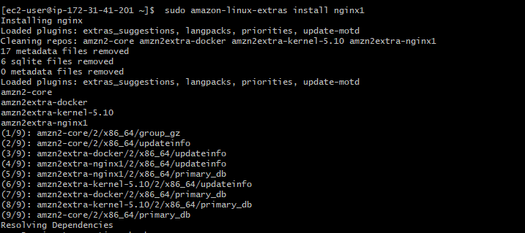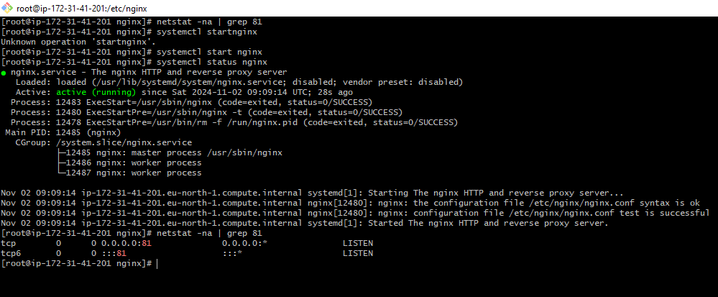

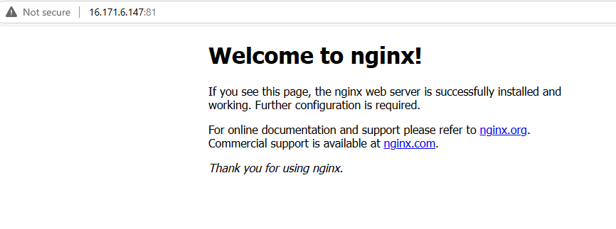

2. Deploy a sample index.html file on nginx.  
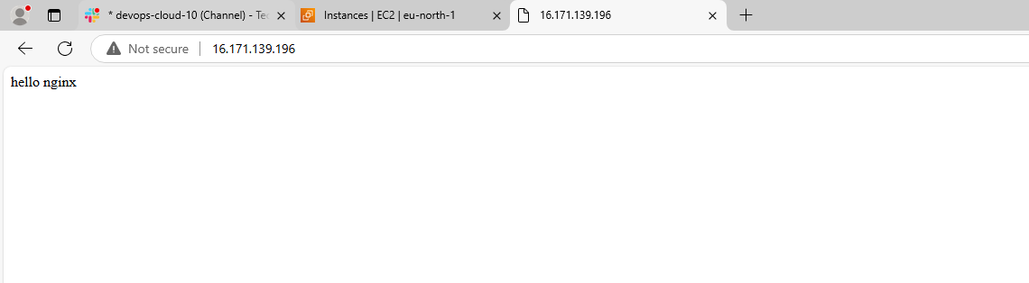

3) Install Apache and run Apache on port number 82  
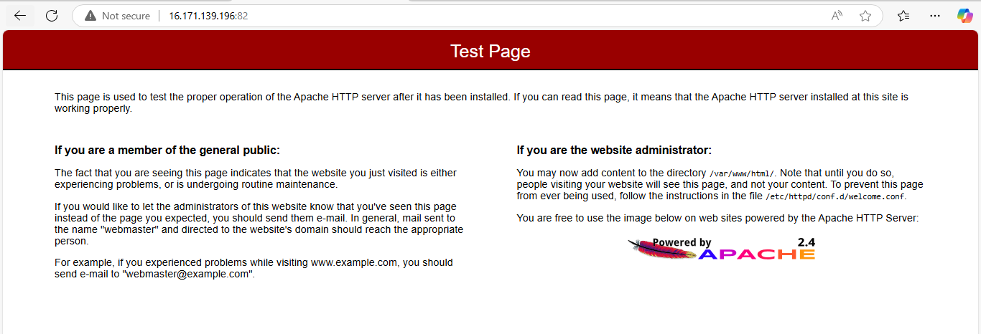

4) Deploy a sample index.html file on Apache.  
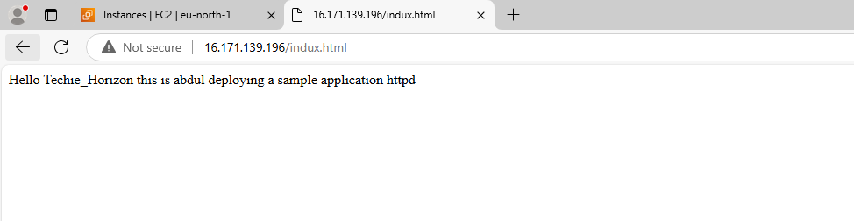

5) Install Apache tomcat on port number 8082  
